Thakur Degree College of Science and Commerce
KANDIVALI (EAST)
MUMBAI
A
PROJECT REPORT
ON
Skill-Edge
For
THAKUR COLLEGE OF SCIENCE & COMMERCE
Shyamnarayan Thakur Marg, Thakur Village, Kandivali (E), Mumbai - 400 101

Designed and Developed
BY: Mr. Vivek Vinod Gupta
Submitted in partial fulfillment of
Bachelors of Science (Computer Science)
[UNIVERSITY OF MUMBAI]
Thakur Degree College of Science and Commerce
Kandivali (East), Mumbai.
ACADEMIC YEAR 2024-2025

CERTIFICATION
FROM
COLLEGE



DATE:
COMPUTER SCIENCE DEPARTMENT
(2024-2025)
Certificate of Approval
This is to certify that the project work entitled “Skill-Edge”is prepared by Mr. Vivek Vinod Gupta a student of “Third Year Bachelor Of Science (Computer Science)”course of University of Mumbai, which is conducted by our college.
This is the original study work and important sources used have been duly acknowledged in the report. The report is submitted in partial fulfillment of B.Sc. (Computer Science) course as per rules of University of Mumbai.

Project Guide Head of Department

External Examiner

ACKNOWLEDGEMENT

ACKNOWLEDGEMENT
Achievement is finding out what you would be doing rather than what you have to do. It is not until you undertake such a project that you realize how much effort and hard work it really is, what are your capabilities and how well you can present yourself or other things. It tells us how much we rely on the efforts and goodwill of others. It gives me immense pleasure to present this report towards the fulfillment of my project.
It has been rightly said that we are built on the shoulder of others. For everything I have achieved, the credit goes to all those who had helped me to complete this project successfully.
I take this opportunity to express my profound gratitude to management of Thakur Degree College Of Science & Commerce for giving me this opportunity to accomplish this project work.
I am very much thankful to Dr. C.T.Chakraborty- Principal of Thakur College for their kind co-operation in the completion of my project.
A special vote of thanks to my faculty, Mr. AshishTrivedi who is our HOD & also our project guide Mrs. Riddhi Mishra for their most sincere, useful and encouraging contribution throughout the project span, without them we couldn’t start and complete the project on time.
Finally, I would like to thank all my friends & entire Computer Science department who directly or indirectly helped me in completion of this project & to my family without whose support, motivation & encouragement this would not have been possible.

(VIVEK VINOD GUPTA)

INDEX

INDEX
Sr. No. | Index Topic | Page
 | Acknowledgement | 7
I. | Introduction
(i) | Description of System | 10
(ii) | Limitations of present system | 10
(iii) | Proposed system and its advantages | 11
(iv) | Requirements Specification | 12
(v) | Activity Chart | 14
II | System Analysis | 16
(i) | Event Table | 18
III | UML Diagram | 21
(i) | Use Case Diagram | 22
(ii) | Component Diagram | 23
(iii) | Deployment Diagram | 23
(iv) | State Diagram | 24
(v) | Class Diagram | 25
(vi) | Collabration Diagram | 25
(vii) | Activity Diagram | 26
(viii) | Sequence Diagram | 28

IV | Data Flow Diagram
(i) | Dataf Flow Diagram(DFD) | 30
V | System Implementation | 31
(i) | Code Implementation | 32
VI | Results | 37
(i) | Test Cases | 38
(ii) | Database Structure | 41
(iii) | ScreenShorts | 46
VII | Future Scope | 51
VIII | Conclusion | 53
IX | References and Bibliography | 55

INTRODUCTION

Description of System
SkillEdge is a comprehensive AI-driven web application designed to analyze student performance and provide personalized guidance. Built with Django, HTML, CSS, and JavaScript, the system offers features like secure JWT-based authentication, performance analysis, AI-driven recommendations, and progress tracking through interactive data visualizations. Students can input academic data, receive customized study plans, and monitor their growth on dynamic dashboards. The responsive design ensures a seamless experience across devices, and the platform also fosters community engagement by connecting students with peers and mentors for collaborative learning.

Limitations of Present System
❌ Manual Data Entry: Requires manual input of performance data, which can lead to errors and reduced efficiency.

❌ Limited Predictive Analytics: The system may not utilize advanced machine learning models for deeper predictive insights.

❌ Lack of Integration: Limited integration with external learning resources or APIs to enhance guidance.

❌ No Mobile App: The absence of a dedicated mobile application limits accessibility on smartphones and tablets.

❌ Scalability Concerns: Potential performance and scalability issues if the user base grows significantly.

- ❌ User Engagement: The community guidance feature might not be fully developed, impacting collaborative learning opportunities.

Proposed System
The proposed SkillEdge system aims to enhance the current platform by introducing advanced features and addressing existing limitations. The new system will automate data input through tools like OCR and spreadsheet import, reducing manual errors.
It will integrate advanced machine learning models to provide predictive analytics and personalized learning insights. External APIs from educational platforms (e.g., Coursera, Khan Academy) will be integrated to offer tailored study resources. A dedicated mobile app for both Android and iOS will improve accessibility and user engagement. The system will leverage cloud services (e.g., AWS, Azure) to ensure scalability and performance for a larger user base. Enhanced community features, including forums and mentorship programs, will promote collaborative learning.
Real-time data visualization with libraries like Plotly or D3.js will provide dynamic insights, while gamification elements such as rewards and progress milestones will keep students motivated throughout their learning journey.

Advantages of Proposed System
✅ Improved Data Accuracy: Automated data input reduces manual errors, enhancing the reliability of performance analysis.

✅ Enhanced Predictive Analytics: Advanced machine learning models provide accurate performance predictions and personalized guidance.

✅ Resource Integration: External APIs offer tailored learning resources, enriching the student experience.

✅ Increased Accessibility: The mobile app ensures users can access the platform on the go, improving engagement.

✅ Scalability and Performance: Cloud integration supports a growing user base with stable and fast performance.

REQUIREMENT SPECIFICATION

1. Hardware Requirements
- Processor: Modern multi-core processor (e.g., Intel Core i5 or equivalent)
- RAM: Minimum of 8 GB
- Storage: SSD with at least 50 GB of free space for development and testing
- Network: Stable internet connection for development, dependency downloads, and version control

2. Software Requirements
- Operating System: Windows, macOS, or Linux
- Python Version: 3.9 or higher
- Django Version: 4.0 or higher
- Database: PostgreSQL, MySQL, or SQLite (depending on configuration)
- Web Browser: Modern browser for testing (e.g., Google Chrome, Mozilla Firefox)
- IDE/Text Editor: Visual Studio Code, PyCharm, or any preferred code editor

3. Front-End Technologies
- HTML/CSS: For structuring and styling the web pages
- JavaScript: For interactive elements and dynamic content
- Bootstrap: For responsive design and UI components
- Charts Library: For data visualization and performance analytics

4. Back-End Technologies
- Django: Framework for developing the SkillEdge web application
- Database: SQLite for lightweight and efficient data management
- JWT Authentication: For secure user login and session management
- Django Apps: Modular apps for authentication, performance analysis, prediction, and community interaction

ACTIVITY CHART

THAKUR COLLEGE OF SCIENCE AND COMMERCE
Department of Computer Science
2024-2025
Student's Name: Gupta Vivek Vinod
Project Name: Skill-Edge
College Name: Thakur College of Science and Commerce.
PHASES | EXPECTED DATE OF COMPLETION | ACTUALTIMING OF COMPLETION | SIGNATURE
Preliminary Investigation | 23/11/24 | 23/11/24
System Analysis | 07/12/24 | 14/12/24
System Designing | 21/12/24 | 04/01/25
System Coding | 25/01/25 | 08/01/25
System Implementation | 15/01/25 | 17/01/25
Testing Phase | 20/03/25 | 20/03/25
Project Submission

SYSTEM ANALYSIS

EVENT
TABLE

EVENT TABLE

ID | Description | Trigger | Response
1 | Sign Up | Submit Signup Form | Go to Login
2 | Login | Submit Login Form | Go to Dashboard
3 | Data Entry | Input Academic Data | Data Reflect
4 | Marks Prediction | Request Mark Prediction | Display Predicted Marks
5 | Performance Analysis | Request Analysis | Show Charts and analysis
6 | AI Recommendation | Analysis Completed | Study Tips
7 | Visualization | View Analytics | Visual Insights
8 | Logout | Logout | Redirect to login

UML
DIAGRAM

Use Case Diagram
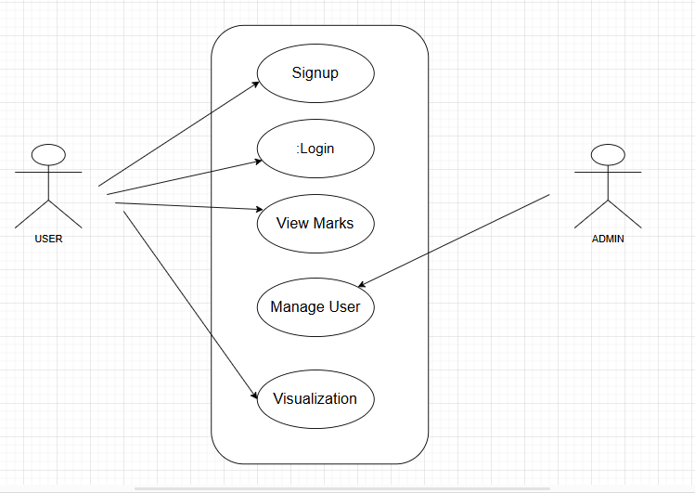

Component Diagram
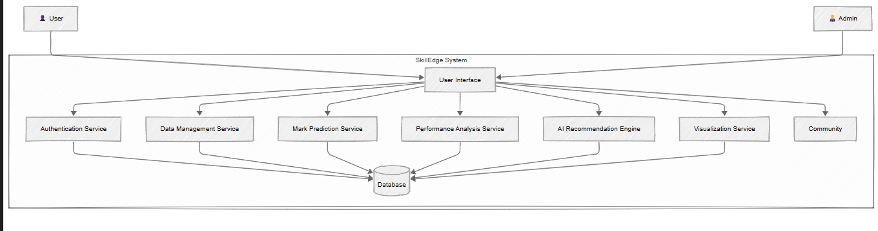

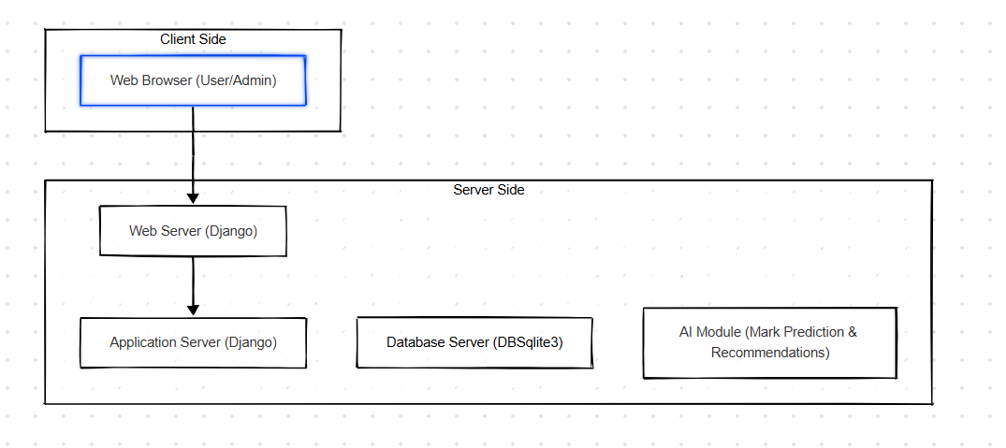
Deployment Diagram

StateDiagram
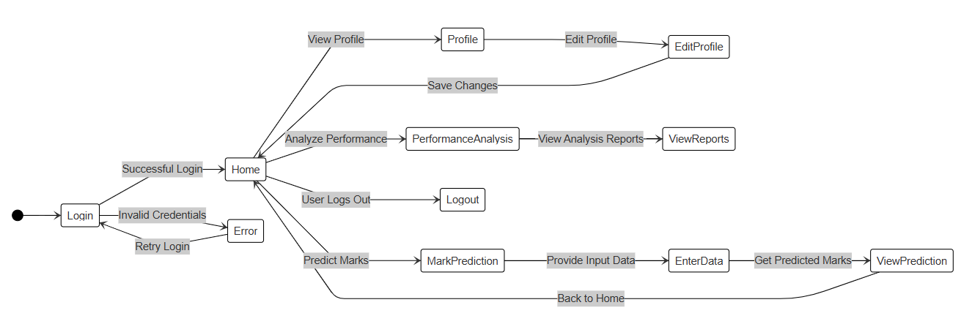

Class Diagram
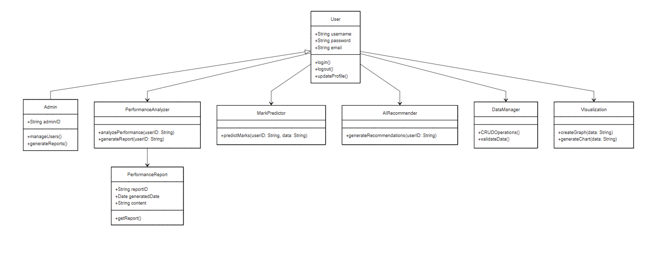

Collaboration Diagram
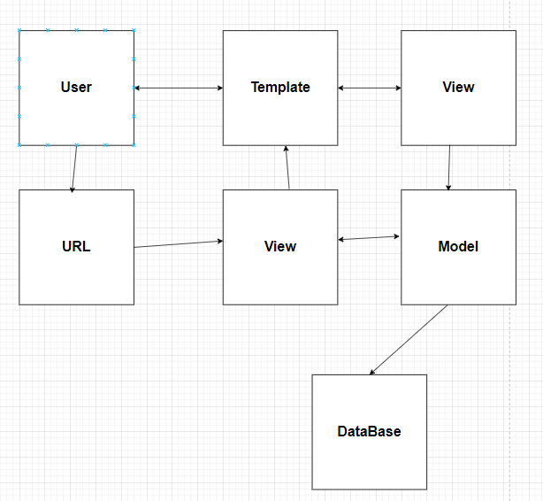

Activity Diagram

REGISTERED USER
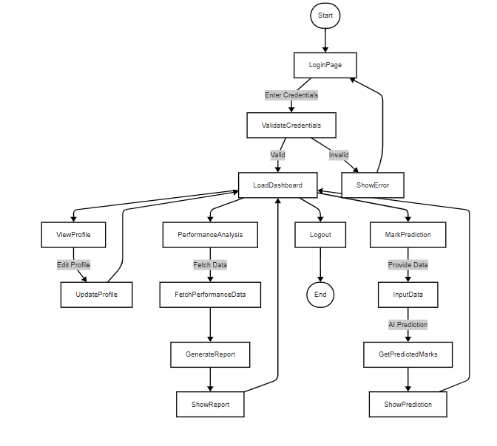

Sequence Diagram

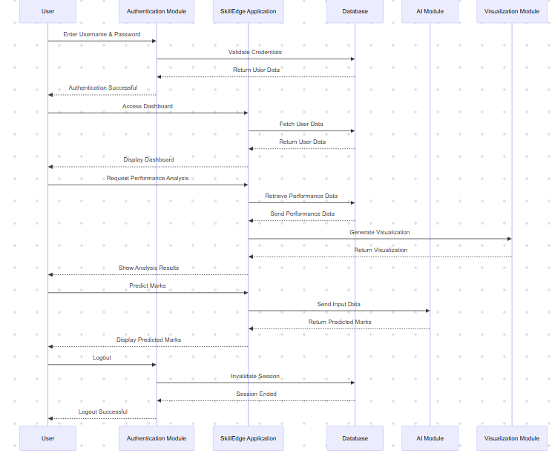

Data Flow
Diagram

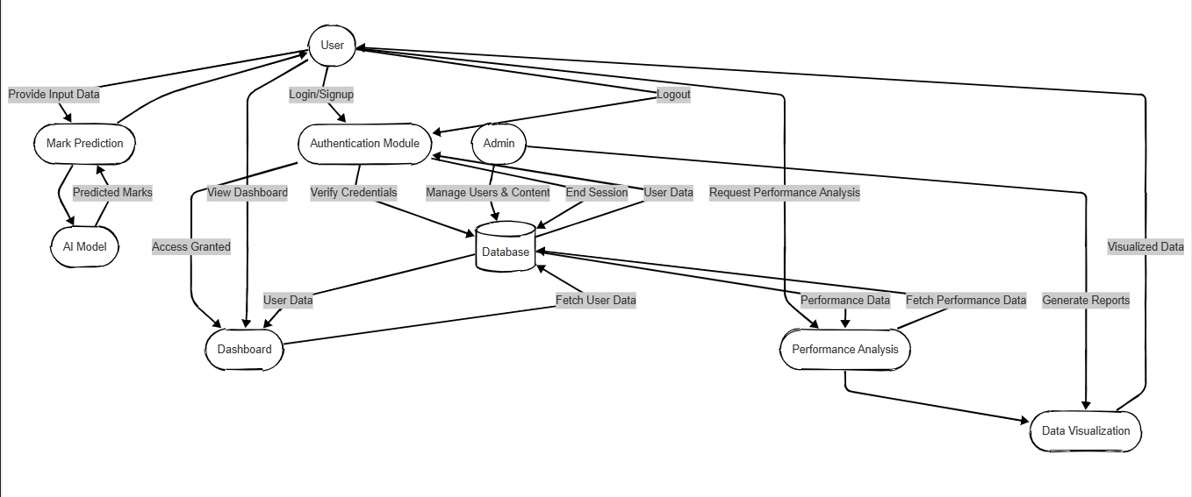

Data FlowDiagram(DFD)

System Implementation

Code Implementation

Views.py
from django.shortcuts import render, redirect , get_object_or_404
from .models import Semester , Subject
from .forms import SemesterForm, SubjectForm
from .prediction_model import predict_next_semester_avg

def manage_performance(request):
semesters = Semester.objects.filter(user=request.user)
semester_form = SemesterForm()
subject_form = SubjectForm()

if request.method == "POST":
if 'add_semester' in request.POST:
semester_form = SemesterForm(request.POST)
if semester_form.is_valid():
semester = semester_form.save(commit=False)
semester.user = request.user
semester.save()
return redirect('manage_performance')

elif 'add_subject' in request.POST:
subject_form = SubjectForm(request.POST)
if subject_form.is_valid():
subject = subject_form.save(commit=False)
subject.semester_id = request.POST.get('semester_id') # Assign semester ID dynamically
subject.save()
return redirect('manage_performance')

return render(request, 'performance/add_performance_data.html', {
'semesters': semesters,
'semester_form': semester_form,
'subject_form': subject_form,
})

def performance_dashboard(request):
semesters = Semester.objects.filter(user=request.user).prefetch_related('subjects')

semester_data = []
for semester in semesters:
subjects = semester.subjects.all()
total_marks = sum(subject.obtained_marks for subject in subjects if subject.obtained_marks is not None)
max_marks = sum(subject.max_marks for subject in subjects)
avg_marks = (total_marks / max_marks) * 100 if max_marks > 0 else 0

semester_data.append({
'semester_name': semester.name,
'avg_marks': avg_marks,
'subjects': [{'name': subj.name, 'marks': subj.obtained_marks, 'max_marks': subj.max_marks} for subj in subjects]
})

# Predict the next semester's average
predicted_avg = predict_next_semester_avg(request.user)

context = {
'semester_data': semester_data,
'predicted_avg': predicted_avg,
}

return render(request, 'performance/performance.html', context)

def delete_subject(request, subject_id):
subject = get_object_or_404(Subject, id=subject_id)

if request.method == "POST":
subject.delete()
return redirect('manage_performance')

return render(request, 'add_performance_data.html', {'subject': subject})

Results

Test Case

Integration Test

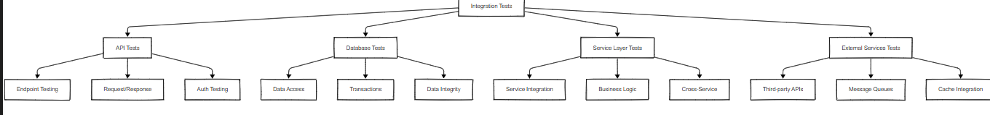

InformationTest
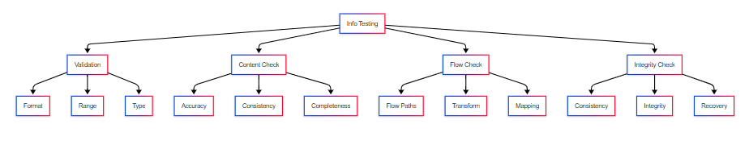

BlackBox Test
Black Box Testing involves only the observation of the output for certain input values,and there is not attempt to analyze the programming code that enables to arrive at those outputs.Therefore,it is also termed “data-driven,input/output driven or requirements based testing”.
Black box testing is also called as”Behavioraltesting”because it only checks the system for certain inputs and doesn’t think about the internal coding.It is concerned with testing the functions of the system.Therefor,it is also called as “Functional Testing”.
No view of the code or any other internal parts system
Input Test Data
Output Data test

DataBase
Structure

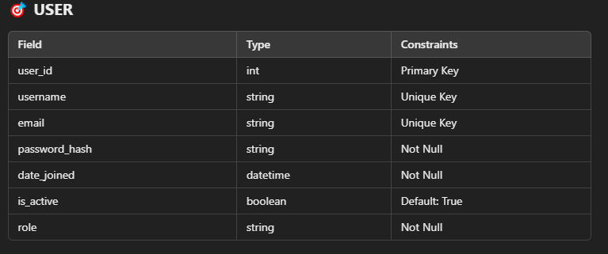

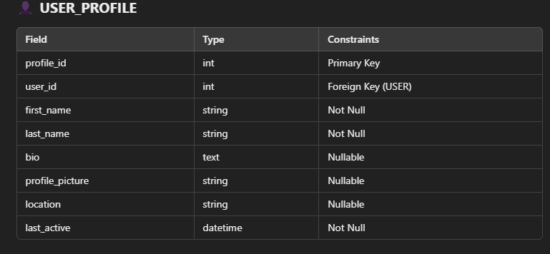

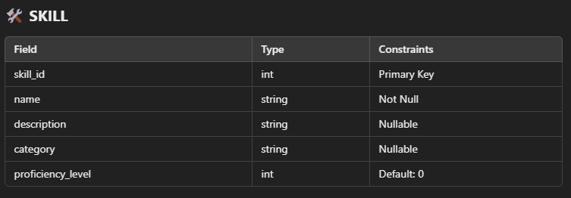

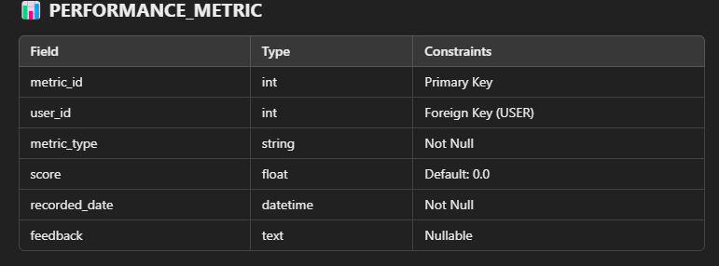
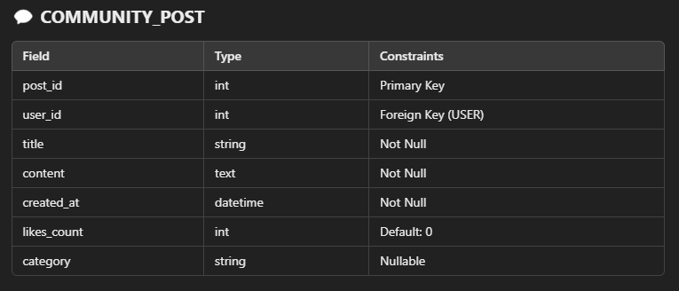

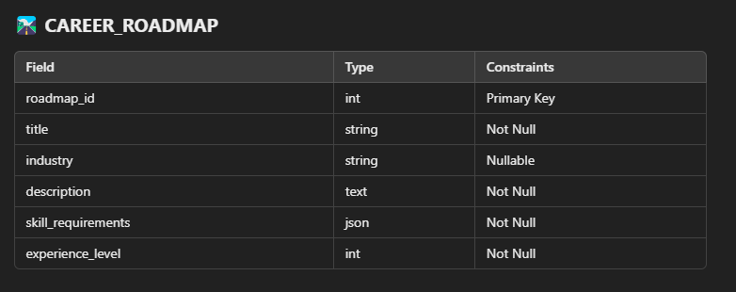

Screenshot

Main Page

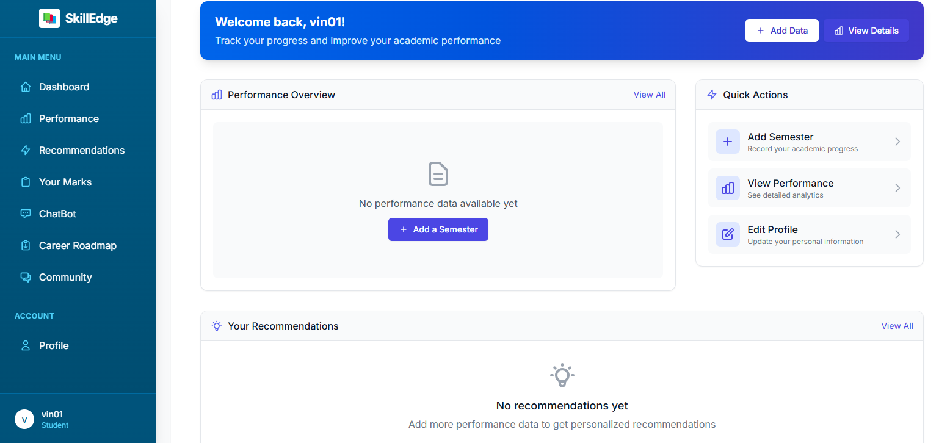

Performance Page

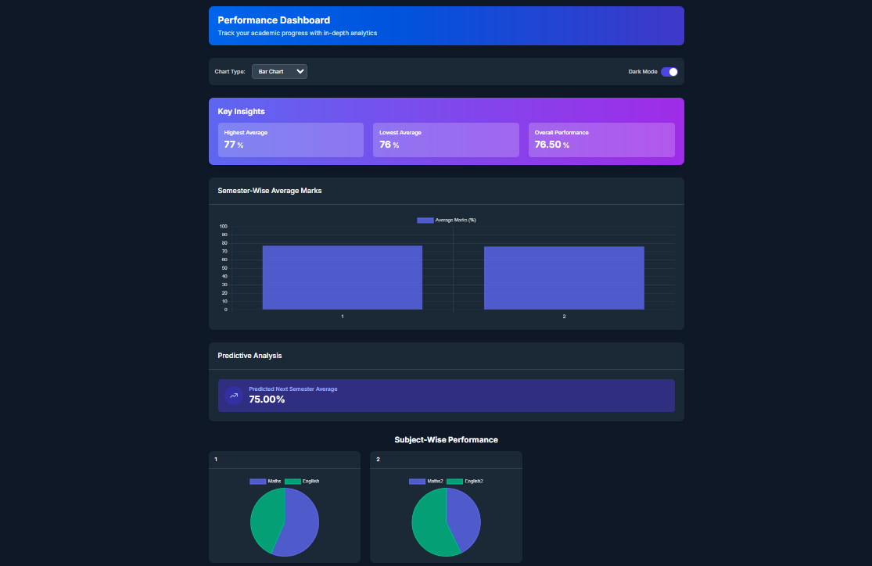

Recommendation

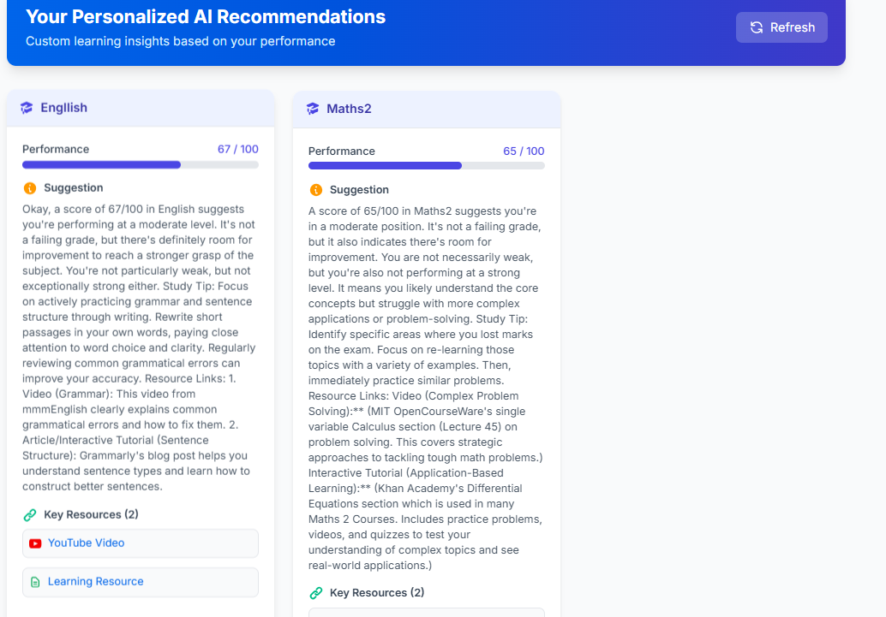

Chat-Bot
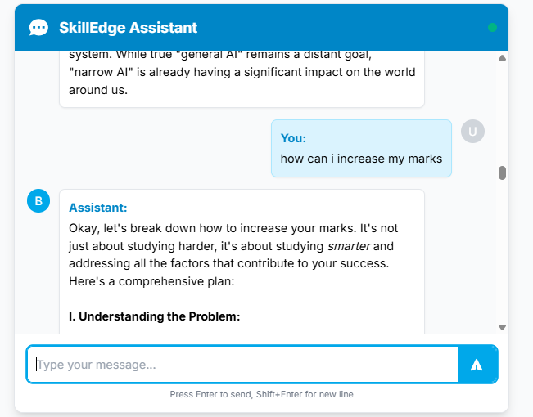

Roadmap

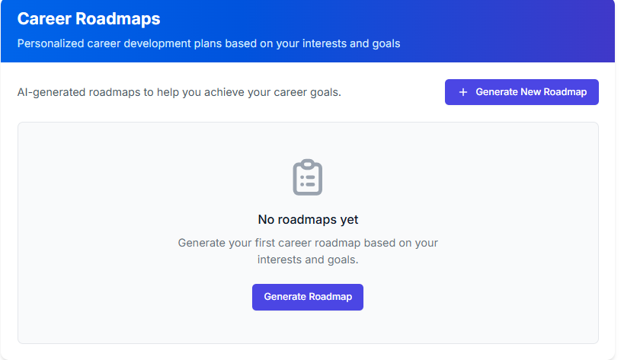

Community Post

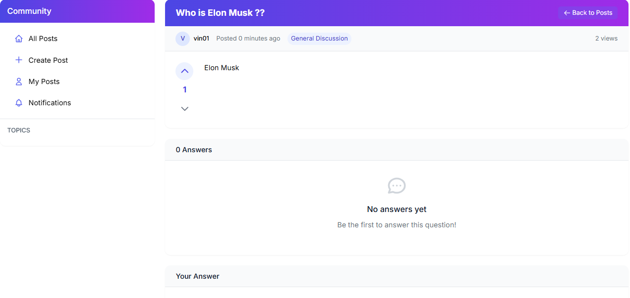

Future Scope

Future Scope
The SkillEdge platform has significant potential for expansion and enhancement across multiple dimensions. In the immediate future, you could implement advanced AI-driven personalized learning paths that adapt to each user's learning style, pace, and career goals. The existing chatbot functionality could be enhanced with GPT-4 or similar advanced language models to provide more sophisticated learning assistance and real-time doubt resolution. A major opportunity lies in incorporating augmented reality (AR) and virtual reality (VR) components for immersive skill training, particularly beneficial for practical skills and hands-on learning experiences.From a community perspective, the platform could evolve into a comprehensive professional networking ecosystem, introducing features like peer-to-peer mentoring, expert consultation sessions, and industry-specific discussion forums.
The career roadmap feature could be enhanced with real-time labor market insights, integrating data from job markets to provide dynamic career guidance and skill requirement updates. Additionally, implementing blockchain technology for verifiable skill certificates and micro-credentials would add significant value, making the platform more attractive to both learners and employers.The recommendation system could be expanded to include predictive analytics that forecast emerging skills in various industries, helping users stay ahead of market demands. Integration with major job portals and professional networks like LinkedIn could create a seamless bridge between skill development and career opportunities. The performance tracking system could be enhanced with gamification elements, including skill badges, achievement levels, and competitive learning challenges to increase user engagement.On the technical side, implementing machine learning algorithms for early detection of learning gaps and potential dropouts could significantly improve completion rates. The platform could also benefit from mobile-first features like offline learning capabilities, microlearning modules, and push notifications for personalized learning reminders. Adding support for multiple languages and localized content would help in global expansion, while integrating with enterprise learning management systems (LMS) could open up B2B opportunities with corporations for employee upskilling programs.Lastly, developing a marketplace feature where industry experts can create and monetize their courses would add a sustainable revenue stream while ensuring fresh, relevant content.
The platform could also explore partnerships with universities and professional certification bodies to offer accredited courses and recognized certifications. These enhancements would position SkillEdge as a comprehensive, future-ready learning ecosystem that addresses the evolving needs of both individual learners and organizations in the rapidly changing digital economy.

CONCLUSION

Conclusion

SkillEdge represents a comprehensive and innovative approach to modern education and skill development in the digital age. The platform successfully integrates multiple crucial components: personalized learning paths, community engagement, career guidance, and AI-powered assistance, creating a holistic learning ecosystem. By combining traditional educational methodologies with cutting-edge technology, SkillEdge addresses the growing demand for flexible, accessible, and relevant skill development opportunities.The platform's strength lies in its multi-faceted approach, offering users not just courses but a complete career development journey.
The integration of AI-powered chatbot assistance, performance tracking, and community features creates an engaging and supportive learning environment. The career roadmap functionality provides clear direction and purpose to users' learning journeys, while the recommendation system ensures personalized and relevant content delivery.The community aspect of SkillEdge fosters peer learning and networking opportunities, essential components in today's interconnected professional world. The performance tracking system enables users to monitor their progress and maintain motivation throughout their learning journey. Furthermore, the platform's scalable architecture ensures it can evolve with technological advancements and changing educational needs.As the job market continues to evolve rapidly, SkillEdge's focus on practical skills and industry relevance positions it as a valuable tool for continuous learning and professional development.
The platform's potential for future enhancements, including AR/VR integration, blockchain certifications, and expanded AI capabilities, ensures its long-term viability and relevance in the educational technology landscape.In conclusion, SkillEdge stands as a testament to the power of combining education, technology, and community to create a meaningful impact on users' professional growth and career development. Its comprehensive approach to skill development, coupled with its future-ready architecture, makes it a significant contribution to the future of education and professional training.

REFERENCES

References:
I referred to the following books and google for completion of my project:

INTERNET REFERENCES:
Reference taken from Websites like
Django :
Official Django documentation was a primary resource for understanding various Django features and best practices for web development.
URL: https://docs.djangoproject.com

Stack Overflow:
Stack Overflow served as a valuable resource for troubleshooting and problem-solving during development.
URL: https://stackoverflow.com

ChatGPT :
I used ChatGPT for Advance Problems and Bugs
URL: https://chatgpt.com
Cursor AI
I used Cursor AI for my frontend and Deployment
URL: https://www.cursor.com/

